Light - 01
CLASS 08 - SCIENCE

 | Section A
1 | Read the text carefully and answer the questions: On the bases of law of reflection imagine that parallel rays are incident on an irregular surface. As we know the laws of reflection are valid at each point of the surface. Using law of reflection rays are constructed at various points. 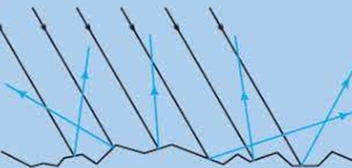  - Which of the following results in diffused reflection?  - a) Wood  - b) Shiny surface  - c) Silver  - d) Plane mirror  - The following diagram represents? 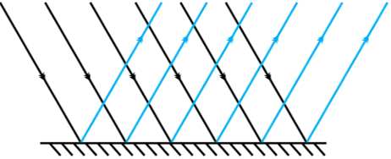  - a) regular reflection  - b) regular refraction  - c) Diffuse reflection  - d) Diffuse refraction  - The reflection of light from a smooth surface is called  - a) spectrum  - b) diffused reflection  - c) regular reflection  - d) dispersion  - ________ is caused by the irregularities in the reflecting surface.  - The bouncing back of light after it falls on a surface is called refraction. | [5]
2 | Read the text carefully and answer the questions: An activity is going in the class by the teacher Step 1 - Fix a white sheet of paper on a drawing board or a table. Step 2 - Take comb and close all its openings except one in the middle. Step 3 - Hold the comb perpendicular to the sheet of paper. Step 4 - Throw light from a torch through the opening of the comb from one side Step 5 - With slight adjustment of the torch and the comb you will see a ray of light along the paper on the other side of the comb. Step 6 - Keep the comb and the torch steady. Place a strip of plane mirror in the path of the light ray. 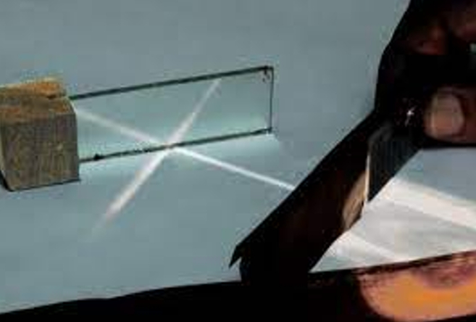  - Beam of light striking the reflecting surface is called  - a) normal ray  - b) incident ray  - c) refracted ray  - d) reflected ray  - The angle of incidence is always ________ to the angle of reflection.  - a) smaller  - b) greater  - c) equal  - d) none of these  - The perpendicular drawn to the reflecting surface is called  - a) reflected ray  - b) none of these  - c) incident ray  - d) normal  - The angle between the normal and the reflected ray is known as the angle of ________.  - The above activity shows laws of reflection. | [5]
3 | Read the text carefully and answer the questions: Step 1 - Get a square piece of cardboard of side 6 - 8 cm. Step 2 - Make two holes. Step 3 - Thread a string through the two holes. Step 4 - Draw/ paste a cage on one side of the cardboard and a bird on the other side. Step 5 - Twist the string and make the card twirl rapidly. 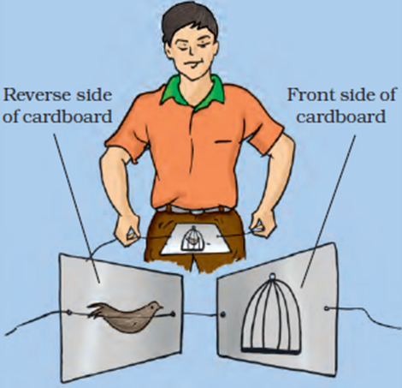  - The impression of an image does not vanish immediately from the retina. It persists there for about  - a) 15 seconds  - b) $\frac{1}{16}$ second  - c) 20 seconds  - d) $\frac{1}{40}$ seconds  - The human eye cannot see clearly at a distance which is less than  - a) 1.5 cm  - b) 25 cm  - c) 2.5 cm  - d) 15 cm  - The human eye can clearly see up to which distance?  - a) 100 km  - b) 1000 km  - c) 10 km  - d) Infinity  - Nature has provided eyes with ________to protect from any object entering the eye.  - Sometimes, in old age, eyesight becomes foggy. It is due to the lens becoming cloudy. | [5]
4 | Read the text carefully and answer the questions: Step 1 - Take two plane mirrors. Set them at right angles to each other with their edges touching. Step 2 - To hinge them you can use adhesive tape. Step 3 - Place a coin in between the mirrors. Step 4 - Now hinge the mirrors using the adhesive tape at different angles, say 45 $​^{o}$ , 60 $​^{o}$ , 120 $​^{o}$ etc. Step 5 - Place some object (say a candle) in between them. Note down the number of images of the object in each case. 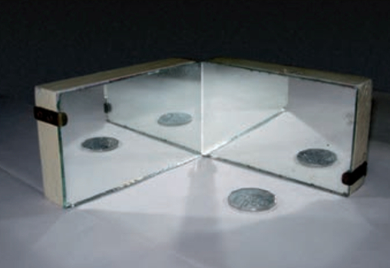  - If two plane mirrors are inclined at an angle of 40°, number of images formed will be  - a) 7  - b) 9  - c) 5  - d) 8  - Whichworks on the concept of multiple reflections?  - a) Sunglasses  - b) Kaleidoscope  - c) Telescope  - d) Binoculars  - kaleidoscope will always give  - a) It will repeat after 1 pattern  - b) same pattern  - c) different pattern  - d) None of these  - In kaleidoscope when peep through the hole, variety of patterns in the tube is seen.  - A candle is 30 cm high. Then the height of its image in a plane mirror ________. | [5]
5 | Read the text carefully and answer the questions: We see things only when light coming from them enters our eyes. Eye is one of our most important sense organs. The eye has a roughly spherical shape. Outer coat of the eye is white. It is tough so that it can protect the interior of the eye from accidents. 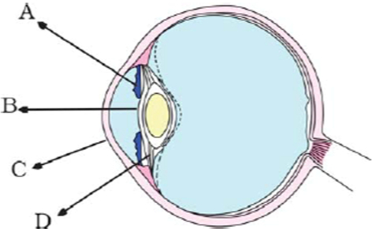  - Which of the following parts of an eye controls the amount of light entering the eye by contracting or dilating?  - a) Pupil  - b) Iris  - c) Retina  - d) Cornea  - Type of cell present on retina  - a) none of these  - b) both cones and rods  - c) rods  - d) cones  - Identify C in the figure given above  - a) Ciliary muscle  - b) Iris  - c) Cornea  - d) Pupil  - The lens focuses light on the back of the eye, on a layer called ________.  - Sensations felt by the nerve cells are then transmitted to the brain through the optic nerve. | [5]
6 | Read the text carefully and answer the questions: Teacher of class 7 teaching the students about how rainbow formed for which she is conducting the following activity.Take a glass prism. Allow a narrow beam of sunlight through a small hole in the window of a dark room to fall on one face of the prism. Let the light coming out of the other face of the prism fall on a white sheet of paper or on a white wall. 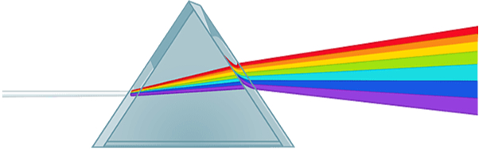  - Which of the following color is seen in Rainbow?  - a) violet  - b) Green  - c) all of these  - d) blue  - The splitting up of white light into seven colors on passing through a glass prism is called  - a) scattering  - b) deflection  - c) refraction  - d) dispersion  - White light is composed of  - a) three colours  - b) five colours  - c) seven colours  - d) eight colours  - ________ is seen as a large arc in the sky with many colours.  - Rainbow can only be seen when your back is towards the sun. | [5]
 | Section B
7 | Assertion (A): Periscope is used in submarines. Reason(R): It follows the application of multiple images.  a) Both A and R are true and R is the correct explanation of A.  b) Both A and R are true but R is not the correct explanation of A.  c) A is true but R is false.  d) A is false but R is true. | [1]
8 | Assertion (A): Lack of vitamin B cause eye disease. Reason (R): We should eat green vegetables.  a) Both A and R are true and R is the correct explanation of A.  b) Both A and R are true but R is not the correct explanation of A.  c) A is true but R is false.  d) A is false but R is true. | [1]
9 | Assertion (A): Reflection from a wooden surface gives parallel rays. Reason (R): Reflection from a plane surface gives regular reflection.  a) Both A and R are true and R is the correct explanation of A.  b) Both A and R are true but R is not the correct explanation of A.  c) A is true but R is false.  d) A is false but R is true. | [1]
10 | Assertion (A): Dust particles are visible due to sunlight. Reason (R): Sunlight gives irregular reflection of light.  a) Both A and R are true and R is the correct explanation of A.  b) Both A and R are true but R is not the correct explanation of A.  c) A is true but R is false.  d) A is false but R is true. | [1]
11 | Assertion (A): Light can be reflected multiple times. Reason (R): The number of two mirrors at some angle gives number of images.  a) Both A and R are true and R is the correct explanation of A.  b) Both A and R are true but R is not the correct explanation of A.  c) A is true but R is false.  d) A is false but R is true. | [1]
12 | Assertion (A): Light falling along normal to plane mirror will retrace its path. Reason (R): Angle of incidence is equal to angle of reflection.  a) Both A and R are true and R is the correct explanation of A.  b) Both A and R are true but R is not the correct explanation of A.  c) A is true but R is false.  d) A is false but R is true. | [1]
13 | Assertion (A): Light focused by lens on the back of eye forms no image. Reason (R): Light focused by lens at the junction of optic nerve and retina forms no image.  a) Both A and R are true and R is the correct explanation of A.  b) Both A and R are true but R is not the correct explanation of A.  c) A is true but R is false.  d) A is false but R is true. | [1]
14 | Assertion (A): Entering into dark room cause strain to the eyes. Reason (R): The size of the pupil becomes large.  a) Both A and R are true and R is the correct explanation of A.  b) Both A and R are true but R is not the correct explanation of A.  c) A is true but R is false.  d) A is false but R is true. | [1]
15 | Assertion (A): Sunlight consists of seven colors. Reason (R): It follows the phenomenon of dispersion of light.  a) Both A and R are true and R is the correct explanation of A.  b) Both A and R are true but R is not the correct explanation of A.  c) A is true but R is false.  d) A is false but R is true. | [1]
16 | Assertion (A): Placing number of mirror at some angle to each other gives multiple images. Reason (R): Number of images formed depends upon number of mirrors.  a) Both A and R are true and R is the correct explanation of A.  b) Both A and R are true but R is not the correct explanation of A.  c) A is true but R is false.  d) A is false but R is true. | [1]
17 | Assertion (A): Braille system used for hearing impaired persons. Reason (R): letters, words, special character can be learned by touching in this system.  a) Both A and R are true and R is the correct explanation of A.  b) Both A and R are true but R is not the correct explanation of A.  c) A is true but R is false.  d) A is false but R is true. | [1]
18 | Assertion (A): An owl can see in night but not in daytime. Reason (R): It has large number of rods and few cones.  a) Both A and R are true and R is the correct explanation of A.  b) Both A and R are true but R is not the correct explanation of A.  c) A is true but R is false.  d) A is false but R is true. | [1]
19 | Assertion (A): Our eye is circular in shape. Reason (R): It shaped like a ball.  a) Both A and R are true and R is the correct explanation of A.  b) Both A and R are true but R is not the correct explanation of A.  c) A is true but R is false.  d) A is false but R is true. | [1]
 | Section C
20 | State True or False:  - The angle of incidence is twice the angle of reflection.  - Too little or too much light is good for eyes.  - Real image is formed by a plane mirror.  - Image formed in a plane mirror is always inverted.  - Regular reflection is produced when light falls on the walls.  - Yellow spot on the retina is highly sensitive to eye.  - Blind spot in eye is found in the eyes of blind people.  - In a telescope the focal length of eye lens is more than objective lens.  - A glass allows almost all the light to pass through it.  - Cornea acts as a window to the world.  - The shadow formed by an object is of the same size as the object.  - Thedistancebetweenprincipalfocusandcentreofcurvatureis called focal length.  - Cones are sensitive to dark light.  - Glass is a transparent body.  - Eyes alone cannot see the objects.  - Opaque objects do not allow light to pass through them.  - A periscope does not work in foggy weather.  - Gold is a translucent metal.  - Reflecting periscope is used by barbers to show the back of head.  - Moon has no light of its own. | [20]
 | Section D
21 | A tiny mirror M is fixed on a piece of cardboard placed on a table. The cardboard is illuminated by light from a bulb. The position of the eye with respect to the position of the bulb is shown in fig, as A, B, C, and D. In which position mirror will be visible? 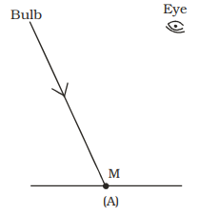  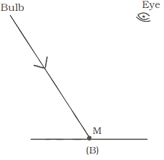  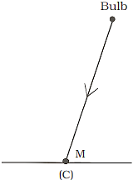  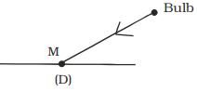  a) A  b) B  c) D  d) C | [1]
22 | Light is falling on surface S$​_{1}$ , S $​_{2}$ , S $​_{3}$ as shown in the figure. 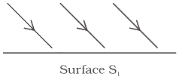  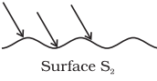  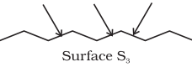  Surfaces on which the angle of incidence is equal to the angle of reflection is/are:  a) S$​_{1}$ and S $​_{2}$ only  b) S$​_{1}$ only  c) All of these  d) S$​_{2}$ and S $​_{3}$ | [1]
23 | Two mirrors A and B are placed at right angles to each other as shown in figure. 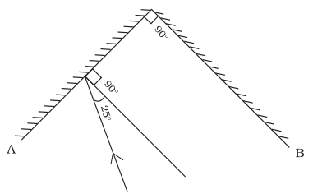  A ray of light incident on mirror A at an angle of 250 falls on mirror B after reflection. The angle of reflection for the ray reflected from mirror B would be:  a) 50$​^{o}$  b) 115$​^{o}$  c) 65$​^{o}$  d) 25$​^{o}$ | [1]
24 | In the figure of the human eye (Fig.), the cornea is represented by the letter 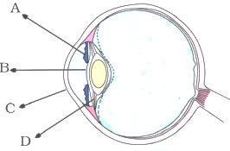  a) C  b) D  c) A  d) B | [1]
25 | A small hole P is made in a piece of cardboard. The hole is illuminated by a torch as shown in fig. The pencil of light coming out of the hole falls on a mirror. 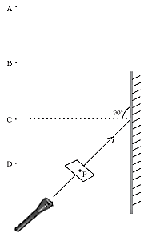  At which point should the eye be placed so that the hole can be seen?  a) B  b) C  c) D  d) A | [1]
 | Section E
26 | Match the items given under Column A with those under Column ’B’. 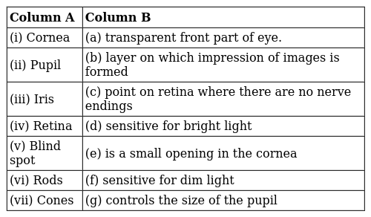 | [2]
27 | Match the following: 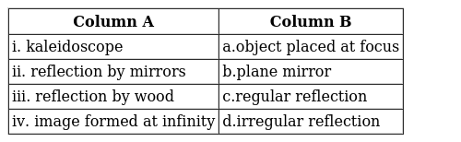 | [2]
28 | Match the following: 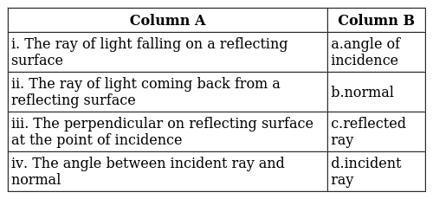 | [2]
29 | Match the items given in Column A with those in Column B suitably: 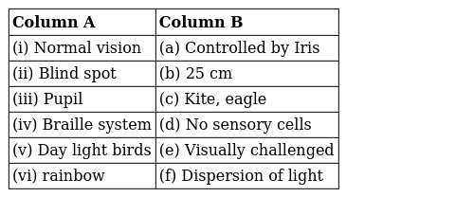 | [2]
30 | Match the following: 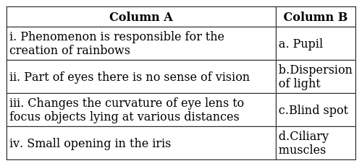 | [2]
31 | Match the following: 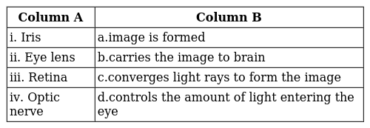 | [2]
32 | Match the following: 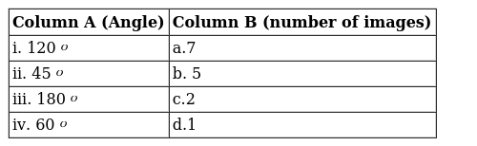 | [2]

